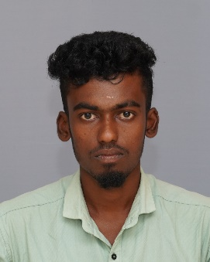

SANTHOSH KUMAR .S

# Contact Phone:

+91 9042418266

# Email:

santhoshkumarsanthoshkumar054@gmail.com

**LinkedIn:**

https://www.linkedin.com/in/santhosh-kumar-4a0723230

# GitHub:

[Santhoshkumar8266 (github.com)](https://github.com/Santhoshkumar8266)

Address:

S/O: Subaramani, 9/60, THOPPUPATTI,PUTHUR, Karur,

Tamil nadu-621313

# Education:

**Master of Computer Application (MCA)**

*Rathnavel Subramaniam College of Arts and Science - Coimbatore*

* From 2021to 2023 **Bachelor of Computer Application (BCA.,)**

*National college of arts and science Trichy.*

* From 2018 to 2021
* 70%

# HSC

*Government Higher Secondary School*

* From 2017 to 2018
* 56%

# Career Objective:

I seeking a challenging position in a reputed organization where I can learn new skills , expand my knowledge, and leverage my learnings

# Projects:

Rathnavel Subramaniam college of arts and science – Coimbatore. (22.01.31)

Portfolio project link:

[**https://santhoshkumar8266.github.io/portfolio-project-1/**](https://santhoshkumar8266.github.io/portfolio-project-1/)

**Portfolio:**

In this project using Html, Css, Javascript languages . I have introduce my self and insert my coding activity link, assignment links,youTubelink.

# Professional Skills

## Front-End:

HTML, CSS,JavaScript

## Backend:

Node.js,MongoDB,

**Hobbies:**

Cricket, Reading books.

# Declaration:

I hereby declare that the information furnished above is true to the best of my knowledge.

SANTHOSHKUMAR .S